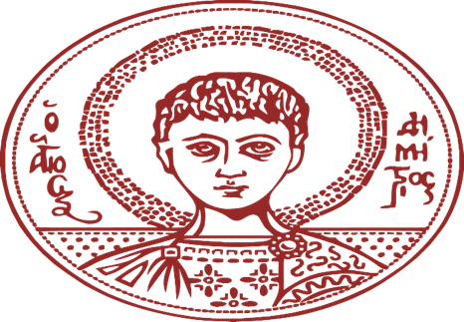
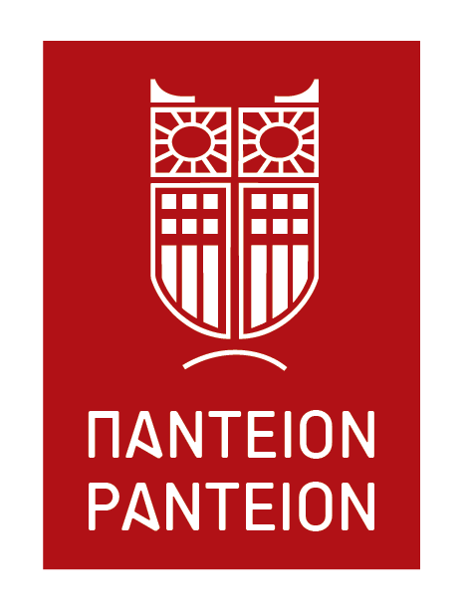

Call for papers for the international colloquium on

“Modern technologies, political philosophy, social, political and economic rights”
The Interdisciplinary Laboratory for Black Sea and Eastern Mediterranean -ILBSEM- of the Aristotle University of Thessaloniki and the Social Policy Lab of the Department of Social Policy of the Panteion University of Athens co- organize international colloquium on the issue of modern technologies and their repercussions, entitled “Modern technologies, political philosophy, social, political and economic rights”.
Modern technologies- such as Artificial Intelligence, cyberspace, algorithms, genetical engineering, synthetic technologies- are already concretely integrated into our lives, often in ways that we do not even notice. They have changed the speed and the type of communication, scientific analysis, decision- making, social interaction, war fighting, our conception of predictive policing, to name only a few of the various sectors upon which they have a catalyst impact.
They further threaten or promise -depending on the perspective- to expand their role in directions such as the merging of human and artificial intelligence, human bio- engineering, data-ism, internet of things, substitution of human labor, nano- robotics and various other, “exotic” transformations, reaching existential depths and the core of the prevalent social and economic model.
The issues at stake are immense. For example: what will be the future of labor? How will our economies change under the impact of modern technologies? In what ways our social interactions will evolve and what lies ahead in terms of privacy and collective forms of social organization? How will modern technologies impact inequality and class antagonisms? How are we going to fight wars in the future? Are we going to experience the emergence of meta- humanism and what will look like? How is the concept of democracy and the one of public sphere changing?
In order to address these issues among others, we organize an international colloquium, aiming at bringing together both students and scholars, from different areas such as political science, economics, philosophy, law.

The proposed themes are the following:
- The trends in modern technologies: what is expected to take place in the next decades regarding technological progress? How obsolete -or not- current technologies will be and what will our world look like?
- Economic transformations: after more than a decade of capitalist crises, what will global economy look like under the influence of autonomous systems, “smart factories”, substitution of human labor, cryptocurrencies etc,? How will economic and social rights influence or be affected by modern technologies? How will inequality be affected both internationally and domestically by modern technologies? What new economic models can emerge on the basis of modern technologies?
- What will be the impact of modern technologies in political and philosophical terms? How will matters such as personality, existentialism, human- centrism and meta-humanism be implicated? Will modernity be relevant? How are forms of collective organization going to be affected by modern technologies? The diffusion of the society of spectacle, fake news, disinformation and over- information. What will be the future of legal philosophy and of legal personality under the influence of modern technologies? Can democracy sustain modern technologies and in what ways?
- The wars of future what do modern technologies mean for the types of wars that we are conducting and for the ones that will emerge in the future? What will cheaper and let hat, post- nuke or mini- nuke wars will look like? A future of killer- robots will come to exist?
The colloquium will be held on the 10th and 11th of December, in Thessaloniki.
The working languages are: English/ Greek
Abstracts should be sent to both of the following emails as “colloquium submission” until the 15th of July:
n.kourachanis@gmail.com;
themis.tzimas@gmail.com

