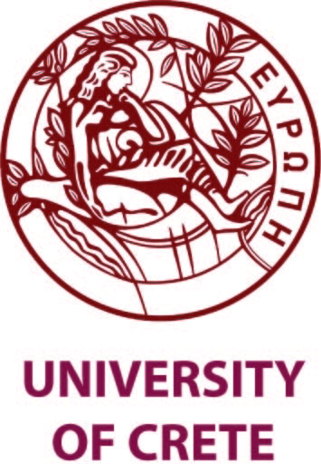 | 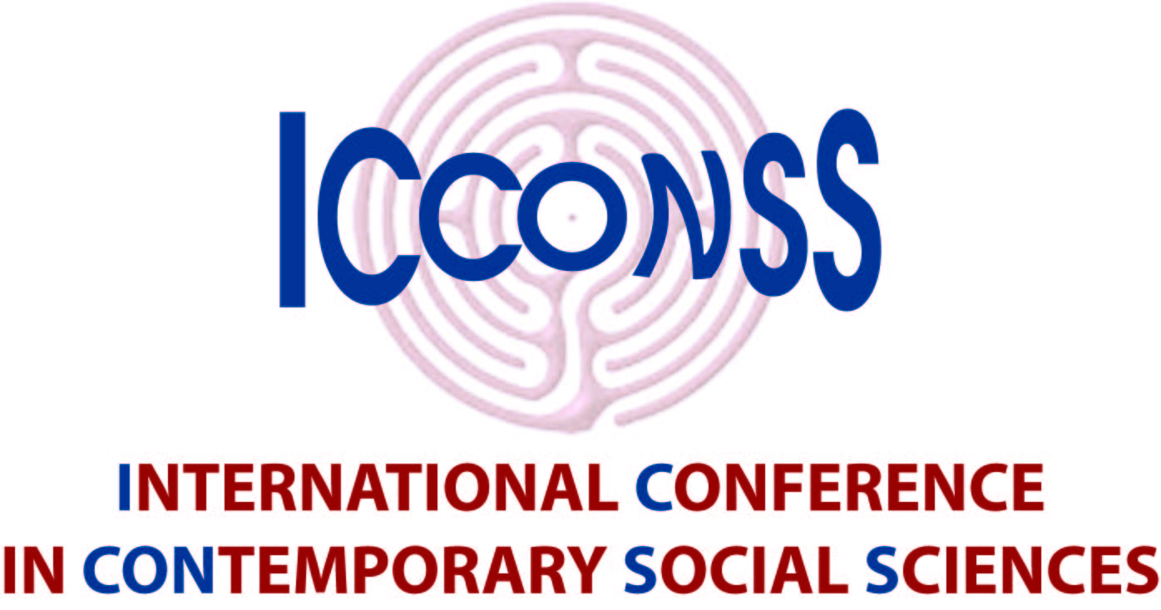 | 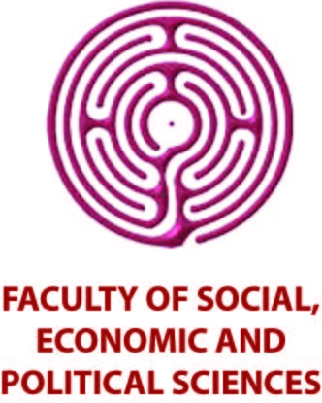

1st INTERNATIONAL CONFERENCE IN CONTEMPORARY SOCIAL SCIENCES

CRISIS AND THE SOCIAL SCIENCES: NEW CHALLENGES AND PERSPECTIVES

Rethymno, 10-12 June 2016

Call for Papers

It is now almost seven years since the onset of the most severe financial and economic crisis that has taken hold in Europe since the 1930s. Since then, multifaceted crises ensued and Greece was and continues to be engulfed by them and at their epicentre. Social scientists have become engrossed in dialogue and debate regarding the impacts, the causes, the ramifications, and most importantly, how to best understand, confront and tackle the many adverse consequences on various aspects of people’s lives. The crisis in all its complex facets constitutes a major challenge for social science, and its predictive, analytical and interpretative power. The multidimensional nature of the character, causes and consequences of the crisis defies simple answers and brings to the fore the need for interdisciplinary methods and approaches trespassing the borders of any individual social discipline. Only through an open and dynamic dialogue between the individual fields that constitute social science will it be possible to address both the seriousness and breadth of the issues posed by the crisis.

The Faculty of Social, Economic and Political Sciences of the University of Crete, aware of this challenge and the interdisciplinary nature of the issues that arise in the aftermath of the crisis, announces the organisation of an international conference on the subject of the crisis and the role of social sciences. Researchers from all fields of social science and related scientific disciplines (including economics, political science, psychology, sociology and social anthropology) are invited to participate. Interdisciplinary approaches are particularly welcome, as are papers focusing on the European and the Greek crisis in particular. Topics include:

- Methodological issues and theoretical inquiries in the study of crises: Social sciences at the crossroad?
- Interpreting the crisis: different economic perspectives.
- Social and economic consequences of the crisis and policy responses: reviews and perspectives.
- Greek crisis and the future of the Euro
- Impacts of economic crisis on labour, employment and education
- Inequality and social exclusion at times of crisis
- Public health and neoliberal economic crises
- Social stratification and crisis.
- State and public policy in the European and global contexts in times of crisis.
- Reform policies and the demand for competitiveness: Public Administration, Education, Taxation, Social Security and Labour Relations in comparative perspectives.
- Business environment, pressure groups and social dialogue: convergence and competition.
- Political parties and electoral de-alignments: Trends and dynamics.
- Political identities, conflicts and divisions: Ideological and cultural aspects.
- Crisis, political communication, and mass media systems.
- Social movements, social activities and civil societies: Practices, claims and issues.
- Democracy and crisis.
- “We” and “Others” in the time of crisis: Cognitive schemata and social stereotypes.
- Mental health impacts of crisis ridden milieus
- Austerity, precarity and subjectivity
- Debt and personhood

Papers, especially interdisciplinary ones, on any other aspect of social science are also welcome.

You are invited to send a title and a summary (up to 500 words) of your proposed paper by the 31st January 2016. Full papers should be submitted by the 31st March 2016. Registration deadline 31 March 2016. Suggestions for panels are also welcome.

USEFUL INFORMATION
University of Crete,
University Campus, Gallos,
741 00 Rethymno, GREECE
tel.: +30 28310 77 405
fax: +30 28310 77 404
website: http://icconss.soc.uoc.gr
e-mail: icconss@soc.uoc.gr

